**Software Requirement Specification (SRS)**

**For**

**Alumni Management System (AMS)**

**Abstract**

The alumni management system is the way alumni can stay connected with college but also connected with the present students. So that the bond between existing students and pass-out students will become strong and there’ll be direct flow of information between them.

An online Alumni management system is a web based application which also helps the institution to trace old students and to trace them for future endeavors. In today’s world Alumni System is a best way to find, connect and communicate with old friends and institution.

The project is visualized to be completed in two phases. The initial phase will be the creation of a simple system it will be used to capture data from present final year students before the end of term. Initially new college students will be given a student_login_ID. Access to the system can help them in building connections to assist them in their projects or for placements. The second phase of development will extend the functionality of the system to allow previous alumni to register.

**1. Introduction**

**1 .1 Purpose:**

This document is meant to delineate the features of AMS, so as to serve as a guide to the developers on one hand and a software validation document for the prospective client on the other.

The alumni management system is the way alumni can stay connected with college but also connected with the present students. So that the bond between existing students and pass-out students will become strong and there’ll be direct flow of information between them. An online Alumni management system is a web based application which also helps the institution to trace old students and to trace them for future endeavors. In today’s world Alumni System is a best way to find, connect and communicate with old friends and institution.

**1 .2 Scope:**

This system allows alumni to connect with each other over the internet, Faculty can update about events, Admin can add faculty or remove.

**1 .3 Definitions:**

AMS- Alumni Management System

SRS- Software Requirement Specification

GUI- Graphical User Interface Stack

**1.4 Overview:**

This system provides an easy solution for student to connect with each other.

**Functional Requirements:**

This section provides requirement overview of the system.

Various functional modules that can be implemented by the system will be -

1. **Registration**

If students want to connect with alumni he/she must be registered. If Student is Alumni of the college and he/she wants to still connect with college and the present student then students must be registered, unregistered student cannot connect with current student and cannot show more detail about the college.

**2. Login**

Student logins to system by entering valid username and password and can talk with other students, access own information document.

**3. Chat**

After successful login student can chat with the alumni which are added into friend list.

**4. Add events**

Faculty can add, update about college events.

**5. Logout**

All users can logout after login whenever they want.

**Requirements:**

1. Alumni

i. Alumni should be able to make request to register himself/herself.

ii. A student should be able to login once the registration is completed.

iii. Alumni should be able to view another alumni and students.

iv. Alumni should be able to post job opportunity.

v. Alumni should be able to chat.

2. Administrator

i. Admin should be able to acknowledge the request for the new alumni.

ii. Admin should also be able to remove the alumni from the alumni list.

iii. Admin should be able to update about events.

3. Student

i. A new student should be able to register himself.

ii. Student should be able to view another alumni and students.

iii. Student should be able to view job opportunity.

iv. Student should be able to chat.

**1.3.1 List of features:**

1. The application should provide facility for alumni to post job opportunities.

2. The application should display all the alumni and students.

3. The application should allow the administrator to acknowledge the request for alumni registration and also to remove the alumni, add information about events.

**Non-Functional Requirements:**

1. **Security**:

In this system authenticate user is important factor.  User authentication will be done by login by email and password

1. **Reliability**:

The main pillar of reliability of the system is the backup of the database.

Which is continuously maintained and update to reflect the most recent changes.

1. **Availability**:

The system should be available at all times. Meaning the user can access it using web browser, only restricted by the down time of the server on which the system runs. In case of a of a hardware failure or database corruption, a replacement page will be shown.

Uptime: It mean 24 * 7 availability

1. **Maintainability**:

A commercial database is used for maintaining the database and application server takes care of the site.

1. **Accessibility**:

Only authenticated users allow to connect with current student and allow to access information of college.

1. **Modularity**:

The System should have user friendly interface.

It should be easily updated, modified and reused.

**1.4** UML Diagrams

**1.4.1** Class Diagram:

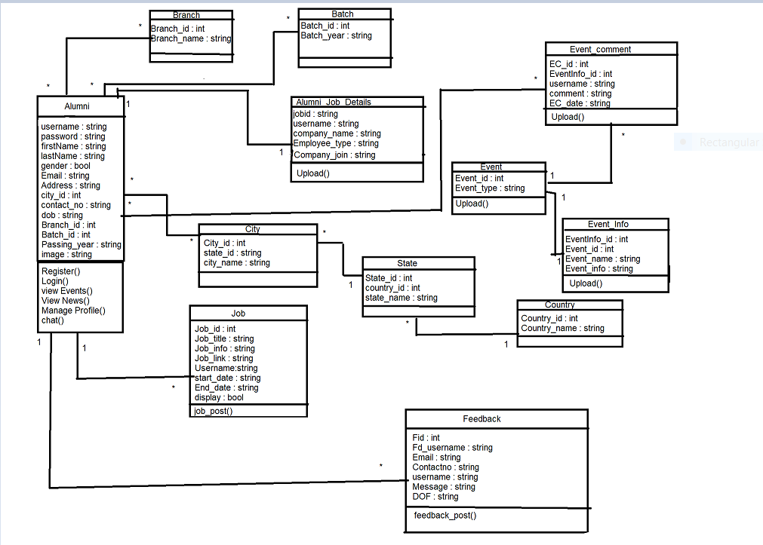

**1.4.2** Use Case Diagram For Admin

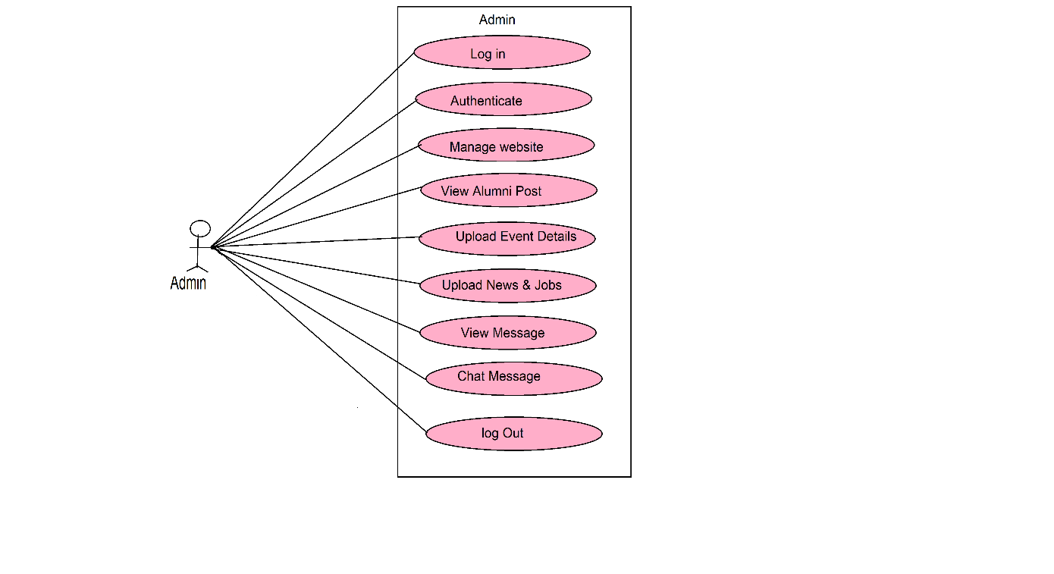

**1.4.3** Use Case Diagram For Alumni

